Project title: Import Data Using Transform Maps

Phase 8: Project Demonstration Phase

1. Detailed System Analytics Reports Breakdown

Three specialized reporting charts were configured using the Reports -> Create New system layout utility to track our data visually:

Report 1: Employees Distribution by Department
- Data Selection Structure: Source Type = Table | Target Schema Table = Employee Test
- Visual Chart Model Type: Pie Chart
- Configuration Parameters: Group By field set to Department | Aggregation mode set to Count.
- Execution Status: Configured, run, and successfully saved.

Report 2: Employees Distribution by Location
- Data Selection Structure: Source Type = Table | Target Schema Table = Employee Test
- Visual Chart Model Type: Bar Chart
- Configuration Parameters: Group By field set to Location | Aggregation mode set to Count.
- Execution Status: Configured, run, and successfully saved.

Report 3: Integrated Employee Grid Inventory List
- Data Selection Structure: Source Type = Table | Target Schema Table = Employee Test
- Visual Chart Model Type: Interactive List View Data Grid
- Configuration Parameters: Selected columns ordered as: Employee ID, Employee Name, Email, Department, and Location.
- Execution Status: Configured, run, and successfully saved.

2. Centralized Employee Analytics Executive Dashboard Workspace

To provide single-screen visibility for stakeholders, a master dashboard named Employee Analytics Dashboard was created via the PA_DASHBOARDS.FORM configuration window.

Using the Share -> Add to Dashboards option inside each report, all three widgets were embedded into a unified workspace. This gives HR teams an easy, visual way to monitor data trends, tracking department and location distributions from one centralized view.

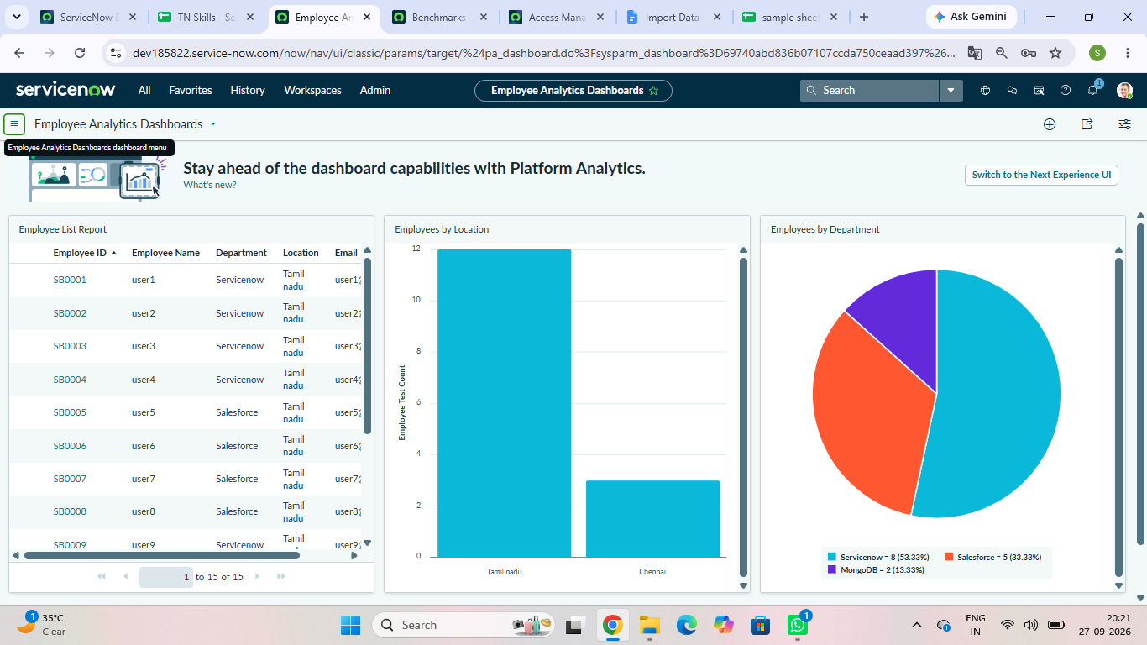

3. Project Deliverables Links and Operational Repository Artifacts

Project Walkthrough Demonstration Video Link:
https://drive.google.com/file/d/1yxNyCZQ-HZQlCKR8TKz_NiwtJKLlqZkl/view?usp=drive_link

Base Testing Asset Data File Link:
https://docs.google.com/spreadsheets/d/162rvaGt-Gf7IFHvqyAeIksQDxHCcaX79SJ0Rt1Ku5cM/edit?usp=drive_link

ServiceNow Instance Verification Status: Complete architecture successfully deployed, validated, and live.

